# Assignment-9

Navigation Bar:



Grid:



Footer:



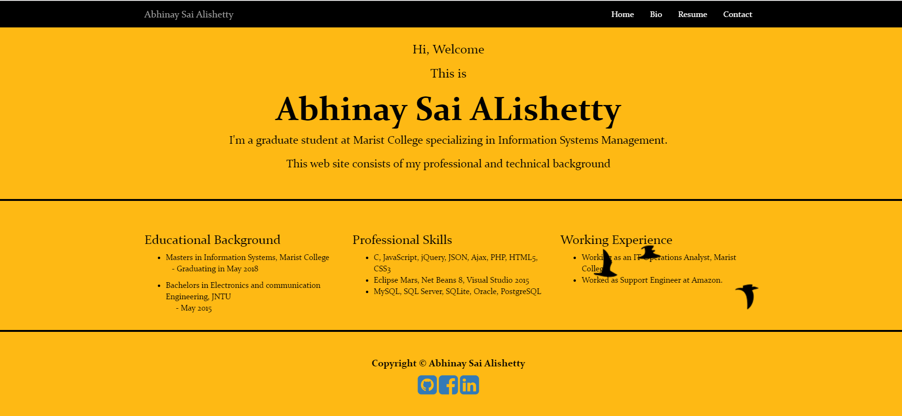

Buttons:





Social networking icons using bootstrap:



I don’t have twitter account so, I have placed github, facebook and linked icons.

I have been using these since my development project 1. In that I have used different icon for facebook and used instgram for linked in.

Here is the proof:

